Ideation Phase

Define the Problem Statements

|  |  |
| --- | --- |
| Date | 19 October 2022 |
| Team ID | PNT2022TMID23730 |
| Project Name | Real time communication system powered by AI for specially abled |
| Maximum Marks | 2 Marks |

**USER PROBLEM STATEMENT:**

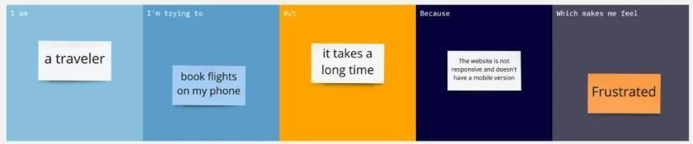

downcasted

Not translated

Communicating via sign to speech

convertor

Deaf-muted

person

Gestures not tracked properly



fettered

Lack of

resources

Normal person

Not matched

Communicating withdeaf- muted person via speech to sign converter

|  |  |  |  |  |  |
| --- | --- | --- | --- | --- | --- |
| **Problem**  **Statement (PS)** | **I am (Customer)** | **I’m trying to** | **But** | **Because** | **Which makes me feel** |
| **PS-1** | Deaf-Muted person | Communicating via sign to speech convertor | Not translated | Gestures not tracked properly | downcasted |
| **PS-2** | Normal person | Communicating with deaf- muted person via speech to signconverter | Not matched | Lack of resources | fettered |